Chinese Brush painting Supply list
1.Semi (half Raw & half ripe) absorbent rice paper or Oriental rice paper.
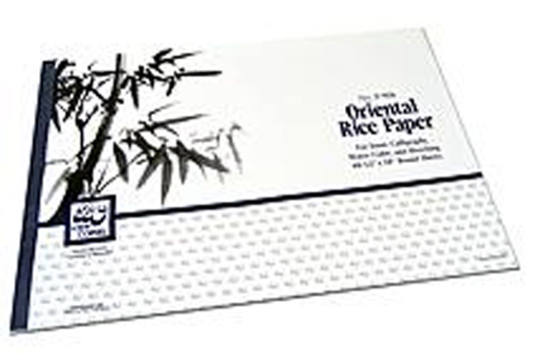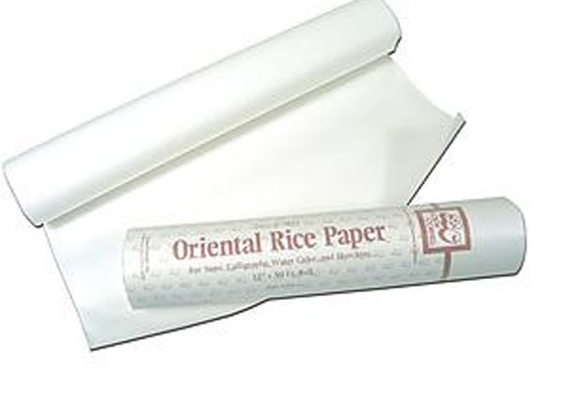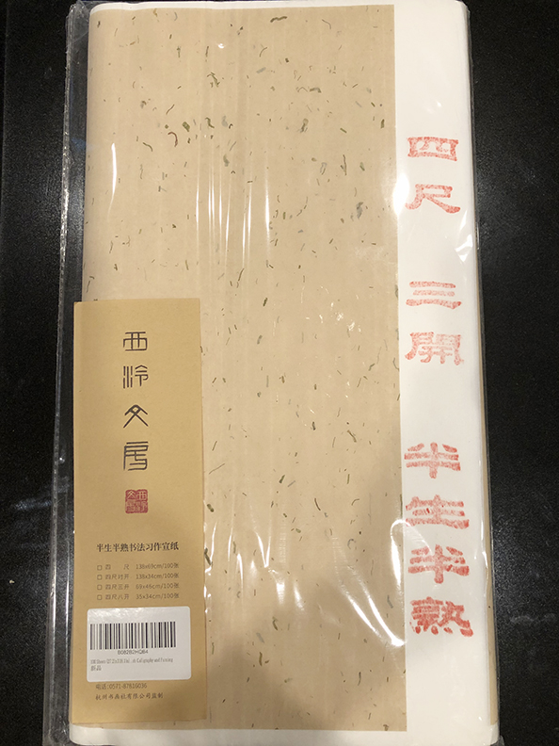
2. Two Paper weights (any weight as rocks)
3. Painting mat or felt (around 18” x 24”)
4. Brushes; one Detail brush or pointed brush
c. Combination brush. Two Small Combination brushes or small hard bristled brush.
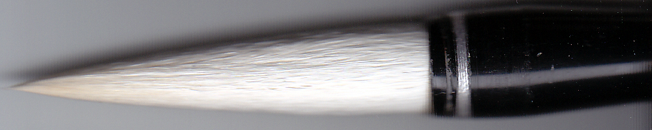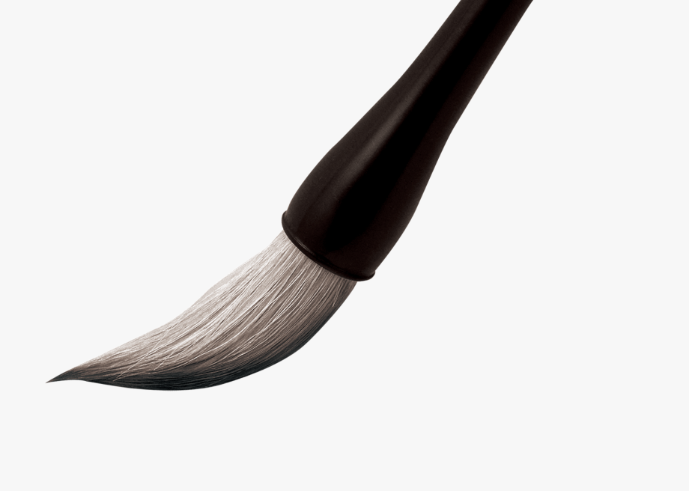
5. A bottle Chinese ink
6. A set of Chinese color (Marie’s watercolor 12 or 18 tubes)
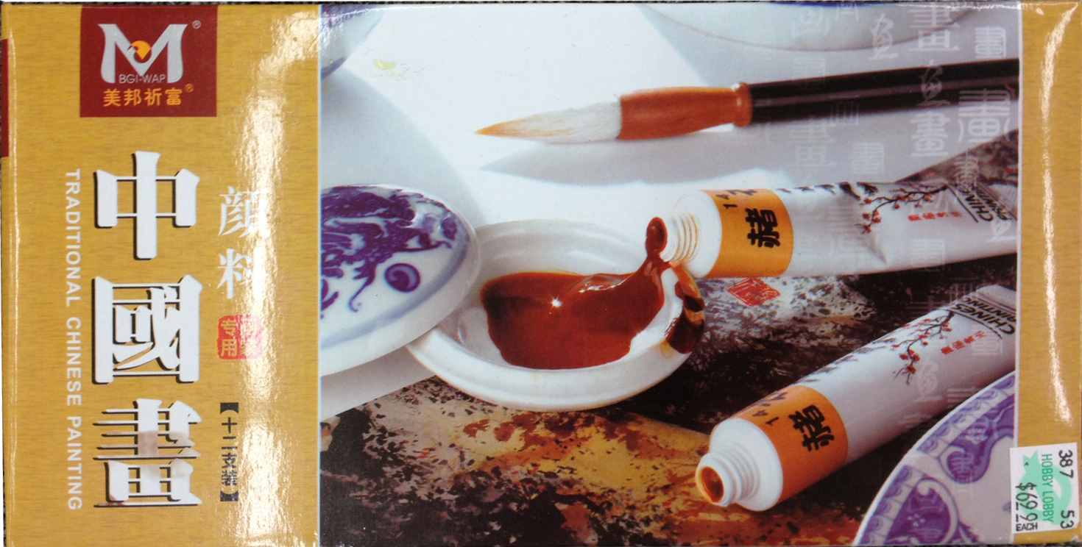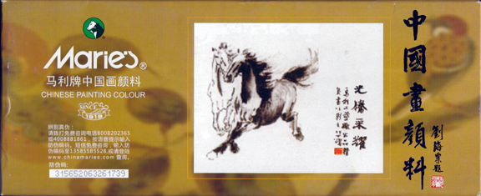
7. Wash Bowl or Jar
8. Palette; any kind of used dishes
9. a roll of paper towel
Where;
- Hobby Lobby (paper, ink not brushes)
- Texas art supply (Ink, oriental rice paper not brushes)
- Art Supply on Almeda Rd. 5301 Almeda Rd. Houston TX 77004
www.orientalartsupply.com or www.jerrysartarama.com or www.amazon.com

